File permissions in Linux

Project description
I examined the file and directory permissions for the research team at my organization to ensure access levels aligned with authorization requirements. Some permissions did not follow the principle of least privilege and allowed unauthorized access. I reviewed existing permissions, updated them to grant appropriate access to authorized users, and removed unnecessary permissions. Below are the performed tasks to manage these permissions:

Check file and directory details
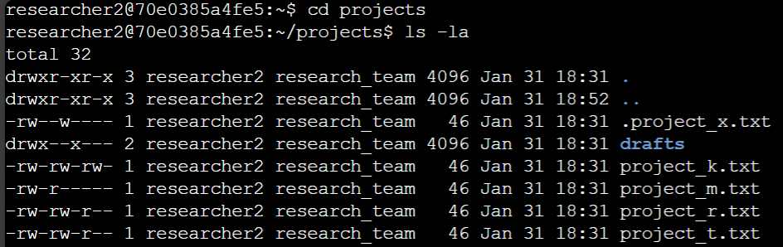
In the first line, I used the cd command to change directories and access the projects. The ls -la command was then used to list down all the files including hidden ones in a detailed format. It can be seen that the user is named researcher2 and belongs to the group research_team. The directory drafts and the hidden file .project_x.txt along with other files was also revealed.

Describe the permissions string
The 10-character string in front of each file can be used to determine the authorization and specific permissions pertaining to it.
- 1st character: This character is either a d or hyphen (-) and indicates the file type. If it’s
a d, it’s a directory. If it’s a hyphen (-), it’s a regular file.
- 2nd-4th characters: These characters indicate the read (r), write (w), and execute (x) permissions for the user. When one of these characters is a hyphen (-) instead, it indicates that this permission is not granted to the user.
- 5th-7th characters: These characters indicate the read (r), write (w), and execute (x) permissions for the group. When one of these characters is a hyphen (-) instead, it indicates that this permission is not granted for the group.
- 8th-10th characters: These characters indicate the read (r), write (w), and execute (x) permissions for other. This owner type consists of all other users on the system apart from the user and the group. When one of these characters is a hyphen (-) instead, that indicates that this permission is not granted for other.

Change file permissions
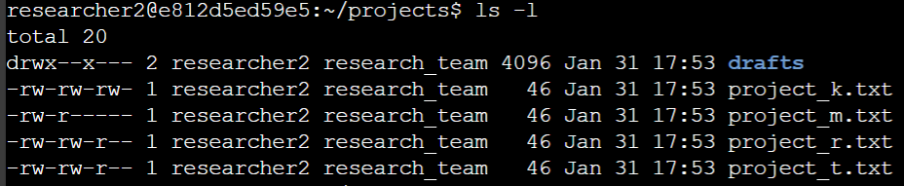
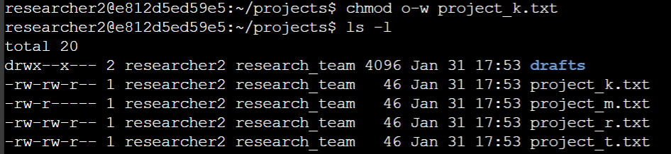
The research team determined that the other users should not have write access to the files. To change the user permissions, I used the chmod command. Since the file project_k.txt is the only one with write access for the other user, it was placed in the second argument. The first argument contained o-w which meant that the write for the other user should be changed.
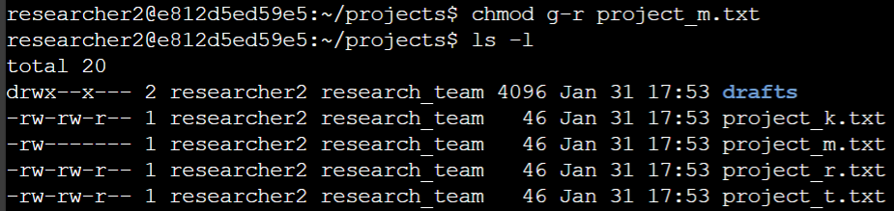
The research team also determined that the file project_m.txt is a restricted file and should not be readable or writeable to the group or other users. I used the chmod command again for the file. Since it previously only had the read permission for the group, I used the g-r as the first argument to change it.

Change file permissions on a hidden file
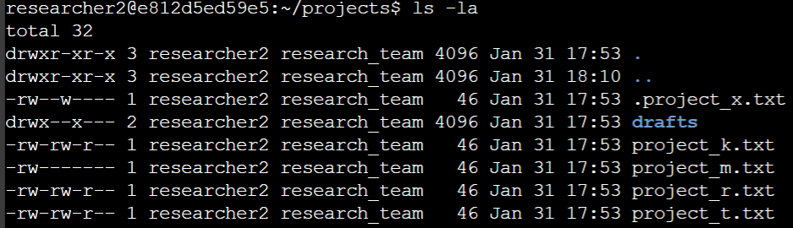
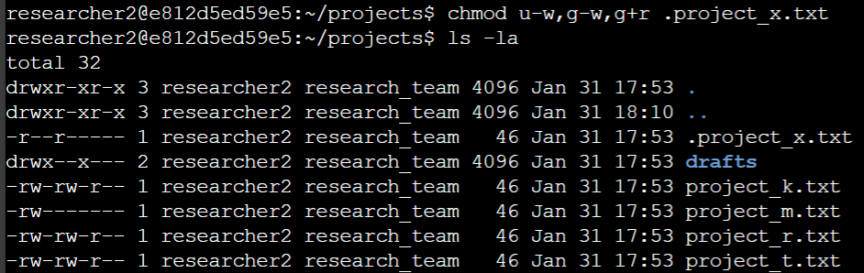
The file .project_x.txt was archived and should not be written to by anyone however the user and the group should still be able to read this. I first used the ls -la command to display the list of files including the hidden ones. The file .project_x.txt is hidden because it starts with a period ( . ). I used the chmod command with the first argument of u-w, g-w, g+r to remove write permission for user and group while adding read permission to the group.

Change directory permissions
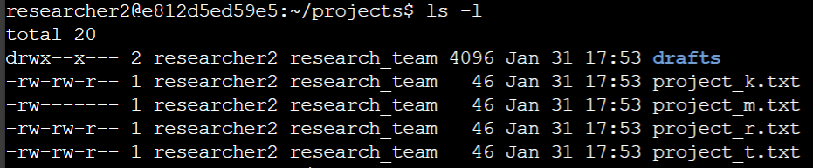
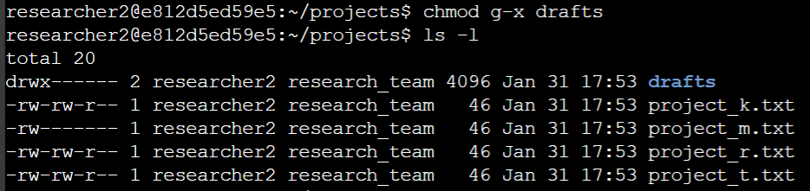
The research team determined that the user researcher2 should be the only one allowed to access the drafts subdirectory. This means executive permission. With the use of the chmod command again, the first argument of g-x removes the executive permission for the group. This leaves the user researcher2 the only one able to write, read, and execute the drafts subdirectory.

Summary
Multiple permissions were altered to match the requirement of the organization for the projects directory. Using the ls -la command shows the list of files in the directory and the permissions for each. Showing the list helps make informed decisions as to what permissions to grant or remove. The chmod command was then used to implement these changes. The command allows changes to the user, group, and other users if they are able to read, write, or execute the file.

